LAB EXPERIMENTS

- Grayscale Conversion
CODE:
import cv2
img = cv2.imread(r"C:\Users\T Rohita Sai\Downloads\cute puppy.jpg")
if img is None:
print("Error loading image")
else:
gray = cv2.cvtColor(img, cv2.COLOR_BGR2GRAY)
cv2.imwrite(r"C:\Users\T Rohita Sai\Downloads\gray_output.jpg", gray)
cv2.imshow("Original", img)
cv2.imshow("Grayscale", gray)
cv2.waitKey(0)
cv2.destroyAllWindows()
OUTPUT:
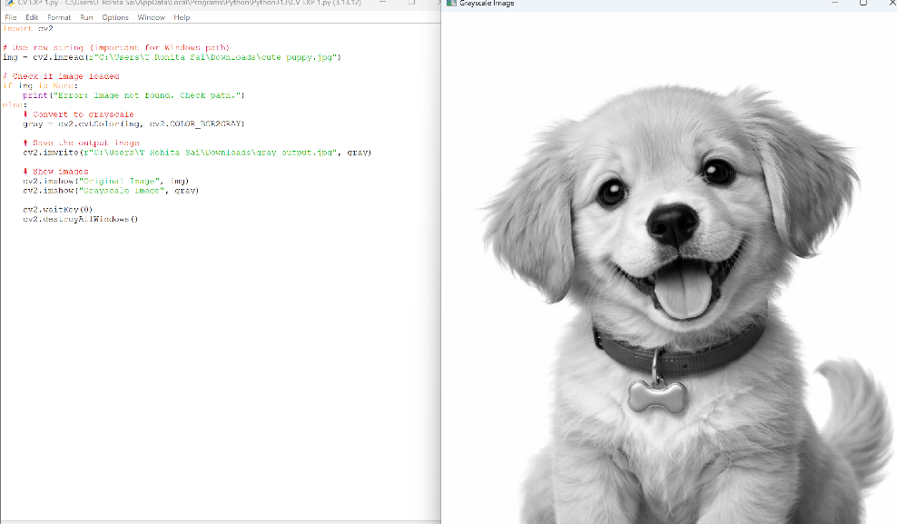

- Gaussian Blur
CODE:
import cv2
img = cv2.imread(r"C:\Users\T Rohita Sai\Downloads\cute puppy.jpg")
if img is None:
print("Error loading image")
else:
blur = cv2.GaussianBlur(img, (5,5), 0)
cv2.imwrite(r"C:\Users\T Rohita Sai\Downloads\blur_output.jpg", blur)
cv2.imshow("Original", img)
cv2.imshow("Blurred", blur)
cv2.waitKey(0)
cv2.destroyAllWindows()
OUTPUT:
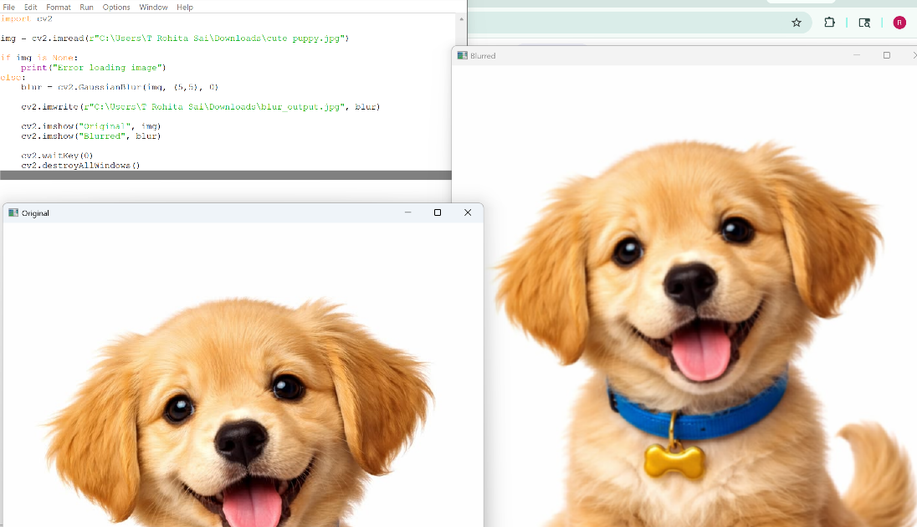

- Canny Edge Detection
CODE:
import cv2
img = cv2.imread(r"C:\Users\T Rohita Sai\Downloads\cute puppy.jpg")
if img is None:
print("Error loading image")
else:
gray = cv2.cvtColor(img, cv2.COLOR_BGR2GRAY)
edges = cv2.Canny(gray, 100, 200)
cv2.imwrite(r"C:\Users\T Rohita Sai\Downloads\edges_output.jpg", edges)
cv2.imshow("Edges", edges)
cv2.waitKey(0)
cv2.destroyAllWindows()
OUTPUT:

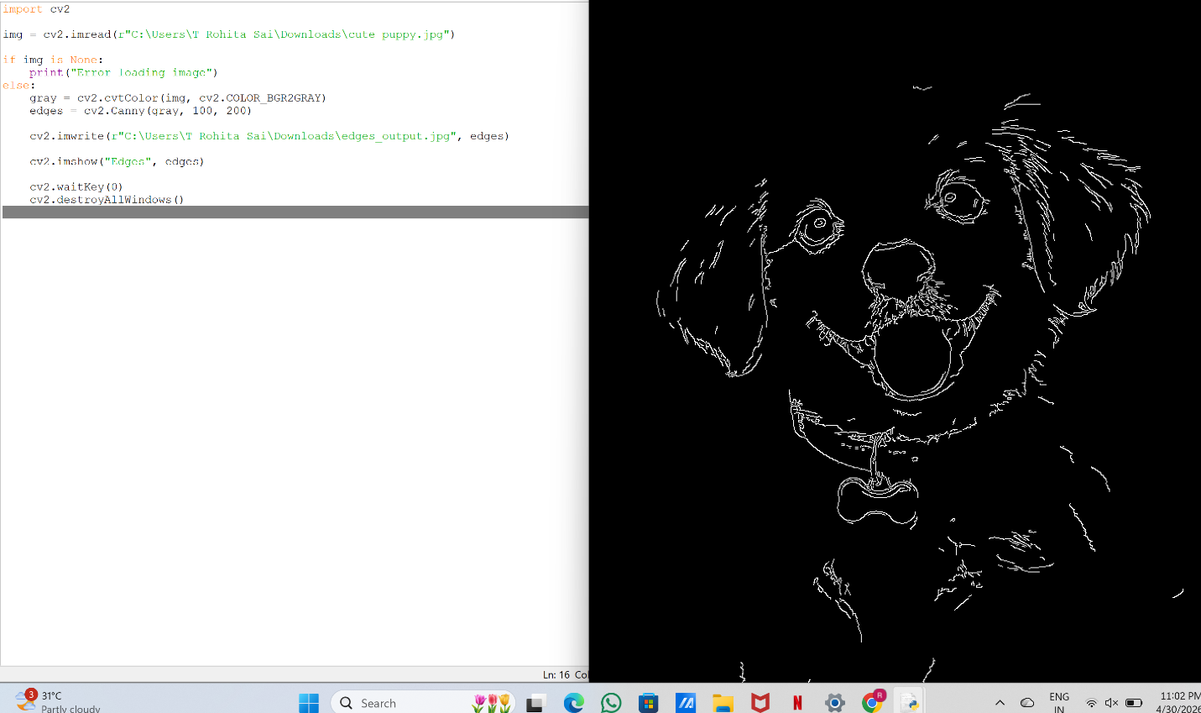
- Histogram Equalization
CODE:
import cv2
img = cv2.imread(r"C:\Users\T Rohita Sai\Downloads\cute puppy.jpg")
if img is None:
print("Error loading image")
else:
gray = cv2.cvtColor(img, cv2.COLOR_BGR2GRAY)
eq = cv2.equalizeHist(gray)
cv2.imwrite(r"C:\Users\T Rohita Sai\Downloads\equalized_output.jpg", eq)
cv2.imshow("Original Gray", gray)
cv2.imshow("Equalized", eq)
cv2.waitKey(0)
cv2.destroyAllWindows()
OUTPUT:

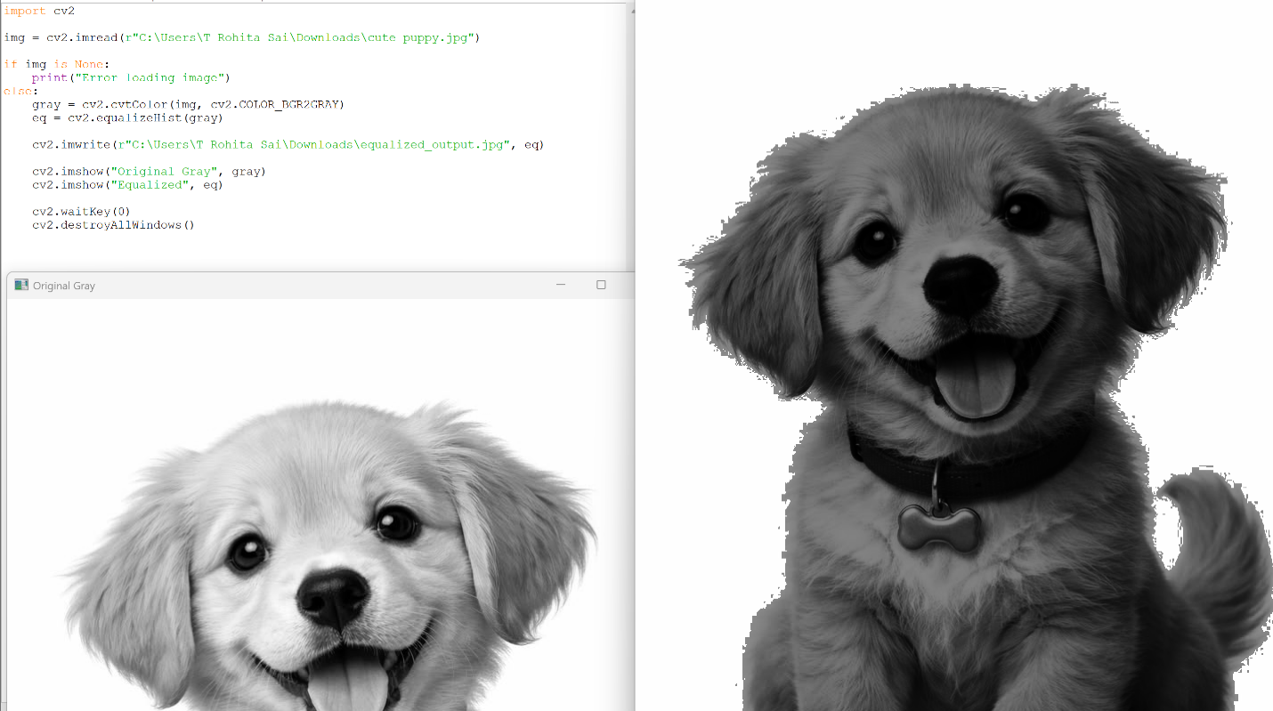
- Histogram Analysis (Color)
CODE:
import cv2
from matplotlib import pyplot as plt
img = cv2.imread(r"C:\Users\T Rohita Sai\Downloads\cute puppy.jpg")
if img is None:
print("Error loading image")
else:
colors = ('b','g','r')
for i, col in enumerate(colors):
hist = cv2.calcHist([img], [i], None, [256], [0,256])
plt.plot(hist, color=col)
plt.title("Color Histogram")
plt.xlabel("Pixel Value")
plt.ylabel("Frequency")
plt.show()

OUTPUT:
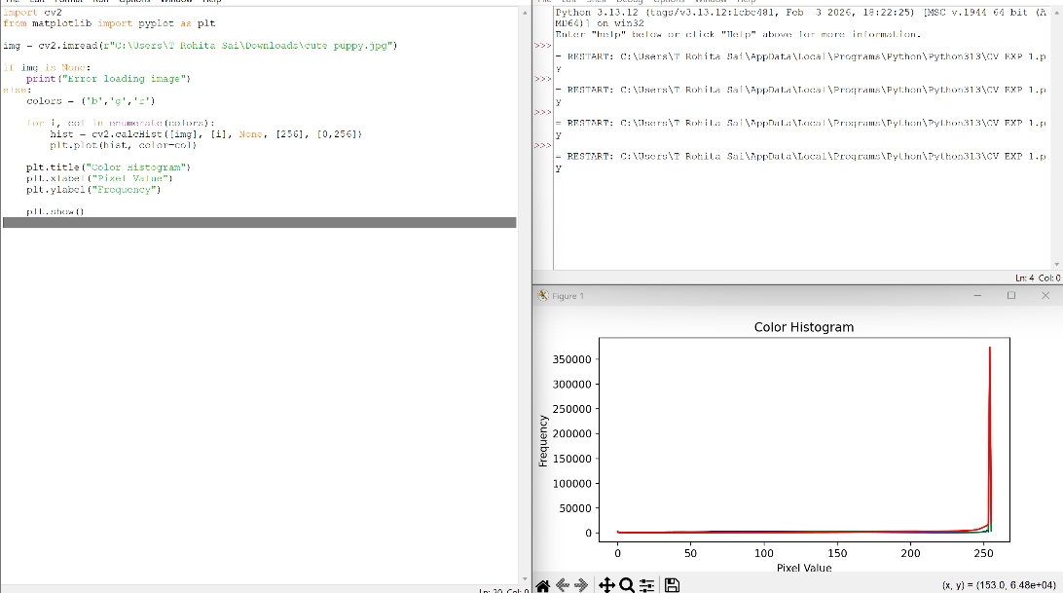

Experiment 6: Erosion (Erode Function)
Code
import cv2
import numpy as np
img = cv2.imread(r"C:\Users\T Rohita Sai\Downloads\cute puppy.jpg")
if img is None:
print("Error loading image")
else:
kernel = np.ones((5,5), np.uint8)
eroded = cv2.erode(img, kernel, iterations=1)
cv2.imwrite(r"C:\Users\T Rohita Sai\Downloads\eroded_output.jpg", eroded)
cv2.imshow("Original", img)
cv2.imshow("Eroded", eroded)
cv2.waitKey(0)
cv2.destroyAllWindows()
OUTPUT:
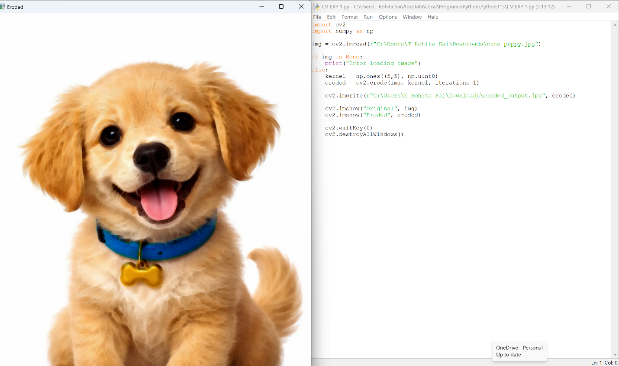

Experiment 7: Video Processing (Normal, Slow, Fast Motion)
Code
import cv2
cap = cv2.VideoCapture(0)
if not cap.isOpened():
print("Error opening camera")
else:
while True:
ret, frame = cap.read()
if not ret:
break
# Normal speed
cv2.imshow("Normal", frame)
# Slow motion (delay ↑)
cv2.imshow("Slow Motion", frame)
cv2.waitKey(100)
# Fast motion (almost no delay)
cv2.imshow("Fast Motion", frame)
if cv2.waitKey(1) & 0xFF == ord('q'):
break
cap.release()
cv2.destroyAllWindows()
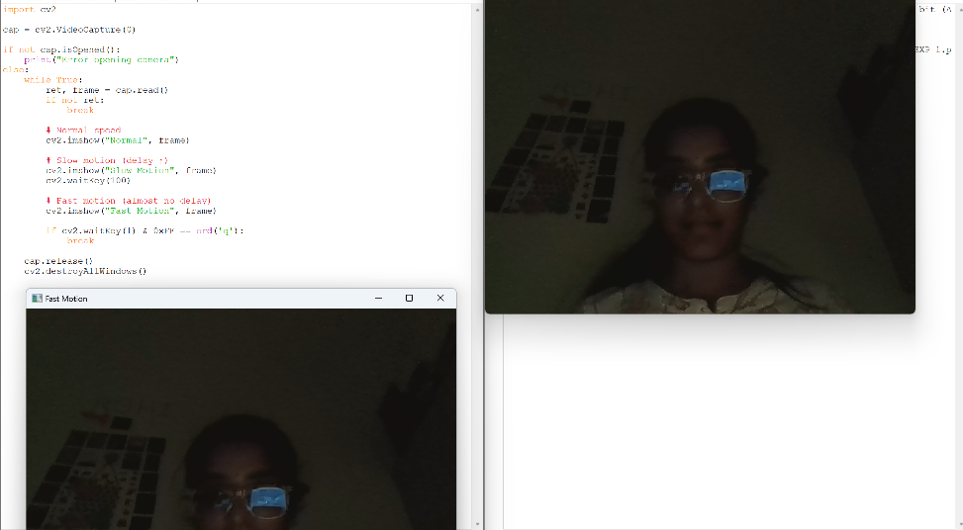
OUTPUT:

Experiment 8: Dilation
Code
import cv2
import numpy as np
img = cv2.imread(r"C:\Users\T Rohita Sai\Downloads\cute puppy.jpg")
if img is None:
print("Error loading image")
else:
kernel = np.ones((5,5), np.uint8)
dilated = cv2.dilate(img, kernel, iterations=1)
cv2.imwrite(r"C:\Users\T Rohita Sai\Downloads\dilated_output.jpg", dilated)
cv2.imshow("Original", img)
cv2.imshow("Dilated", dilated)
cv2.waitKey(0)
cv2.destroyAllWindows()
OUTPUT:
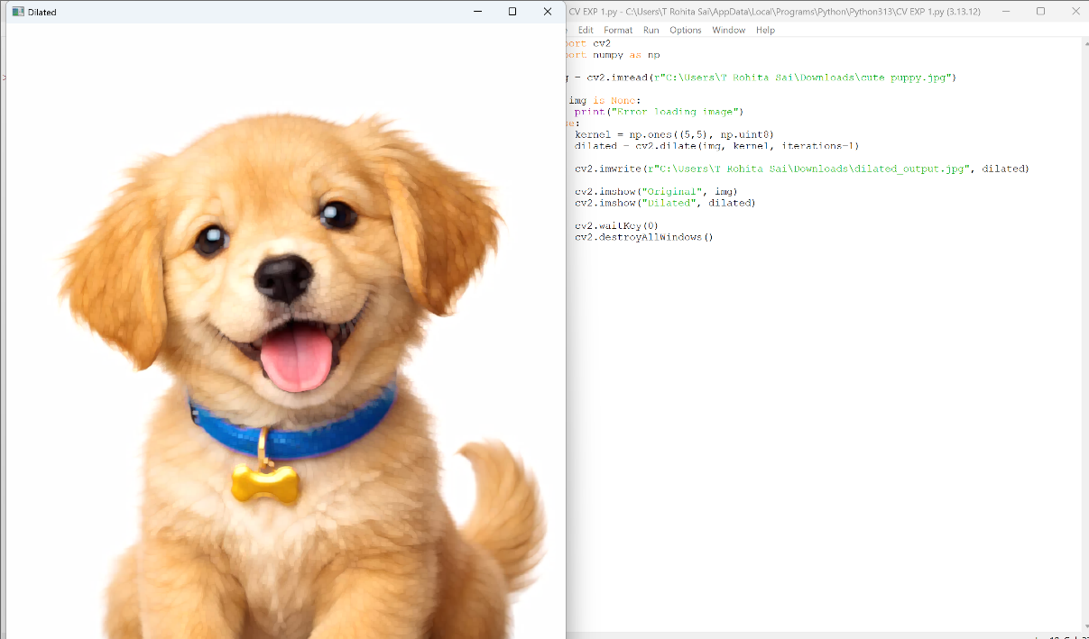

Experiment 9: Image Scaling (Resize Bigger & Smaller)
Code
import cv2
img = cv2.imread(r"C:\Users\T Rohita Sai\Downloads\cute puppy.jpg")
if img is None:
print("Error loading image")
else:
# Smaller image
small = cv2.resize(img, None, fx=0.5, fy=0.5)
# Bigger image
big = cv2.resize(img, None, fx=2, fy=2)
cv2.imwrite(r"C:\Users\T Rohita Sai\Downloads\small_output.jpg", small)
cv2.imwrite(r"C:\Users\T Rohita Sai\Downloads\big_output.jpg", big)
cv2.imshow("Original", img)
cv2.imshow("Small", small)
cv2.imshow("Big", big)
cv2.waitKey(0)
cv2.destroyAllWindows()
OUTPUT:
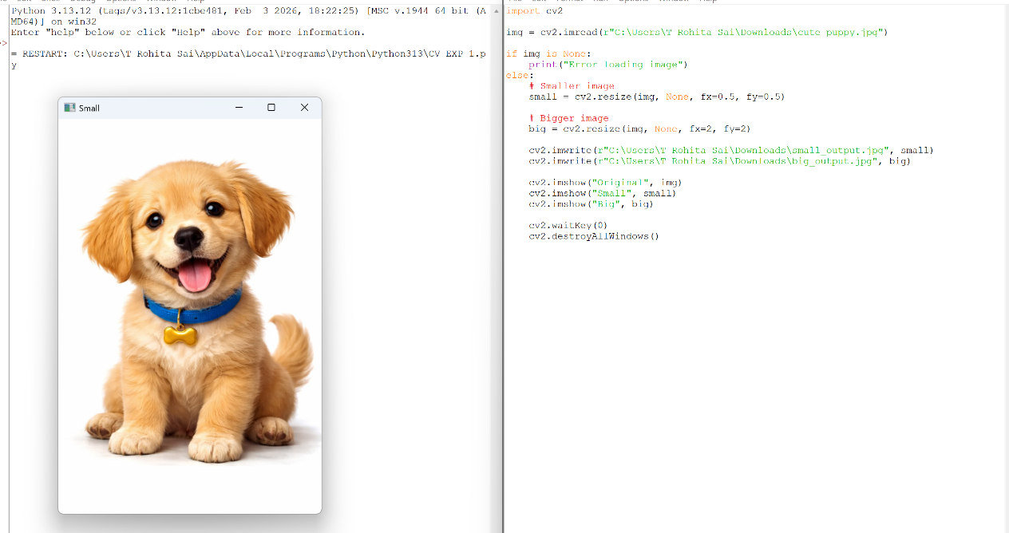

Experiment 10: 90° Rotation (Clockwise)
Code
import cv2
img = cv2.imread(r"C:\Users\T Rohita Sai\Downloads\cute puppy.jpg")
if img is None:
print("Error loading image")
else:
rotated = cv2.rotate(img, cv2.ROTATE_90_CLOCKWISE)
cv2.imwrite(r"C:\Users\T Rohita Sai\Downloads\rotated_output.jpg", rotated)
cv2.imshow("Original", img)
cv2.imshow("Rotated 90 CW", rotated)
cv2.waitKey(0)
cv2.destroyAllWindows()
OUTPUT:
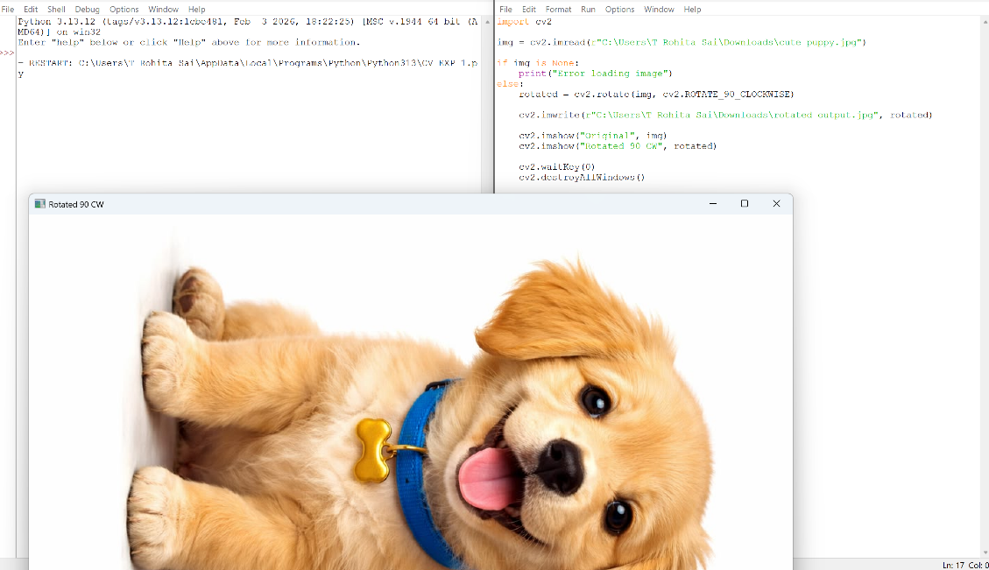

Experiment 11: 180° Rotation

Code
import cv2
img = cv2.imread(r"C:\Users\T Rohita Sai\Downloads\cute puppy.jpg")
if img is None:
print("Error loading image")
else:
rotated = cv2.rotate(img, cv2.ROTATE_180)
cv2.imwrite(r"C:\Users\T Rohita Sai\Downloads\rotate180_output.jpg", rotated)
cv2.imshow("Original", img)
cv2.imshow("180 Degree Rotation", rotated)
cv2.waitKey(0)
cv2.destroyAllWindows()
OUTPUT:
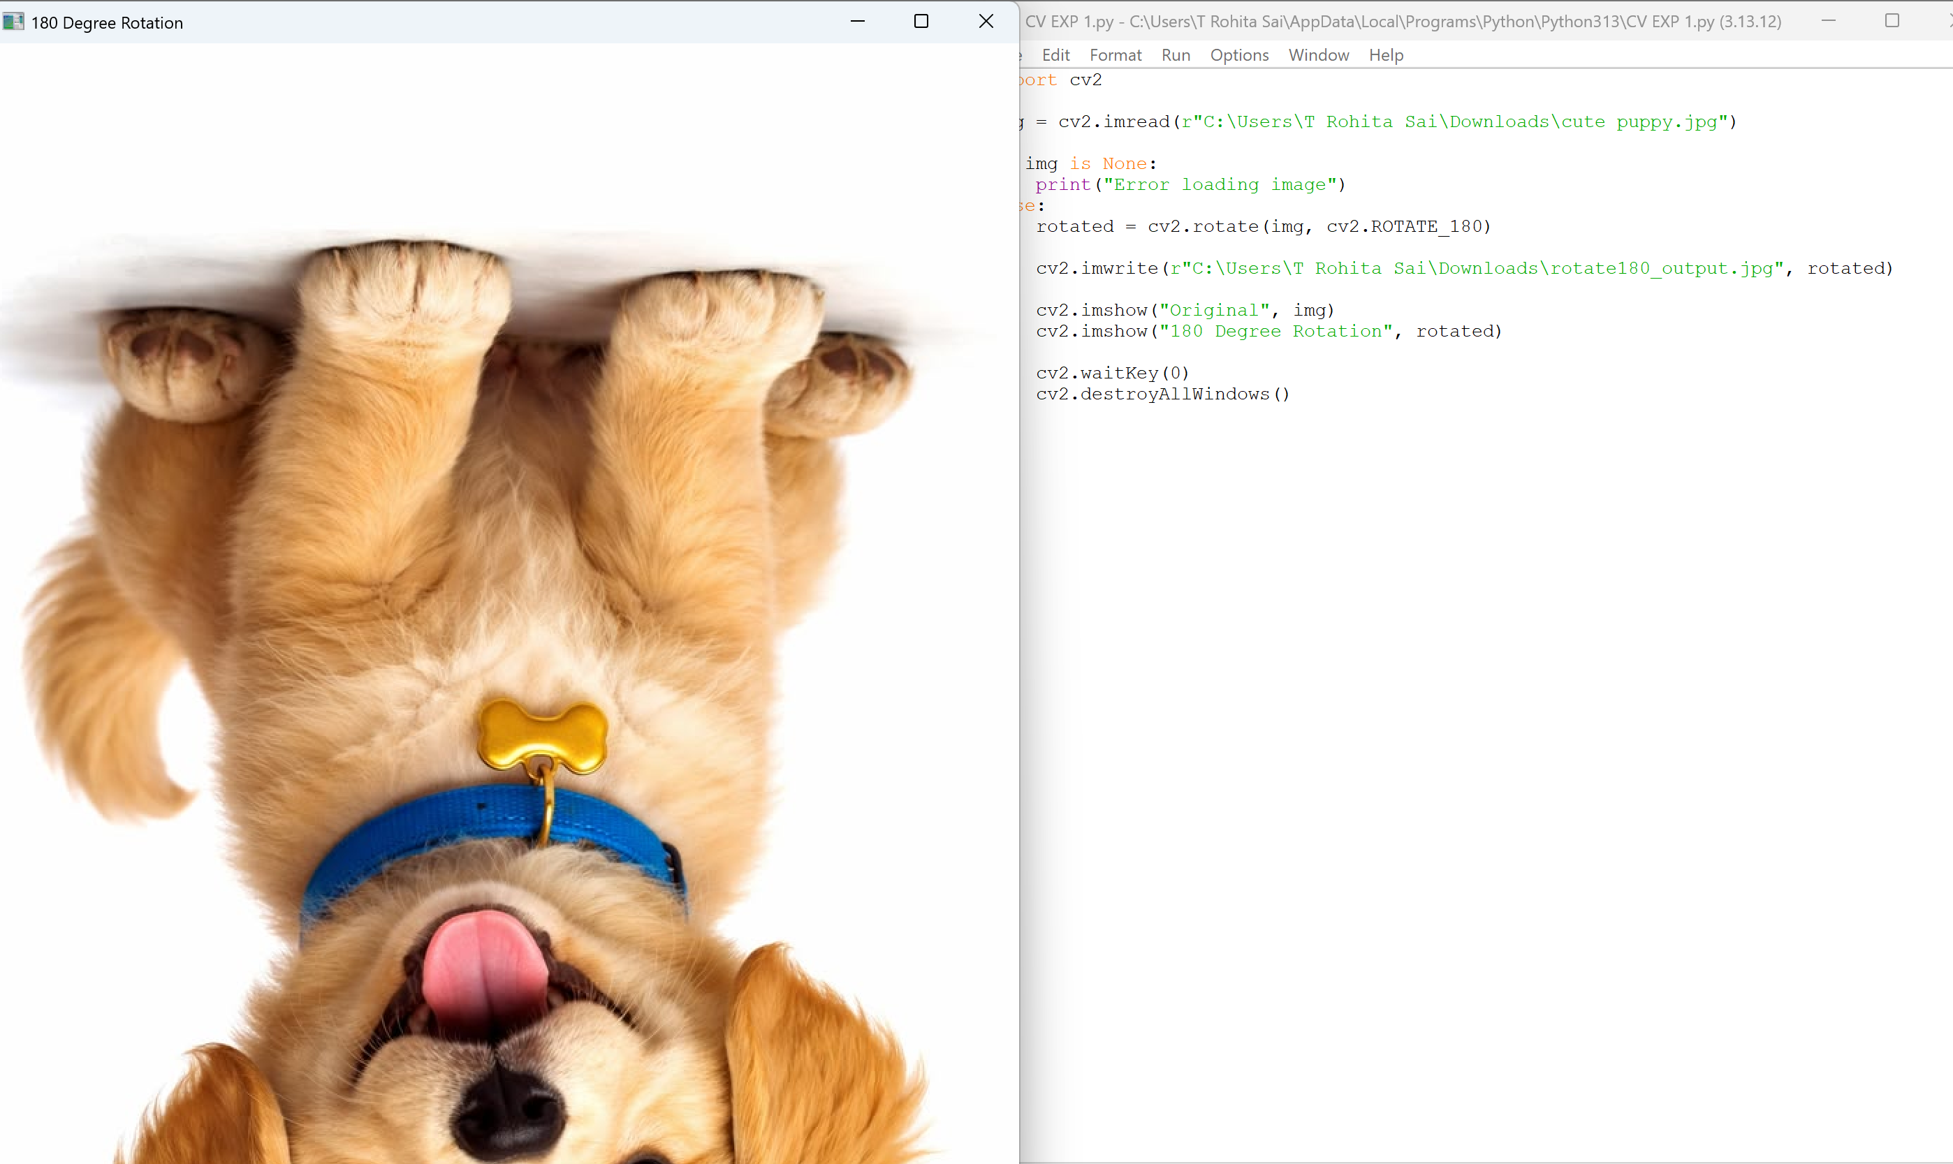

Experiment 12: 270° Rotation Clockwise
Code
import cv2
img = cv2.imread(r"C:\Users\T Rohita Sai\Downloads\cute puppy.jpg")
if img is None:
print("Error loading image")
else:
rotated = cv2.rotate(img, cv2.ROTATE_90_COUNTERCLOCKWISE)
cv2.imwrite(r"C:\Users\T Rohita Sai\Downloads\rotate270_output.jpg", rotated)
cv2.imshow("Original", img)
cv2.imshow("270 Degree Rotation", rotated)
cv2.waitKey(0)
cv2.destroyAllWindows()
OUTPUT:
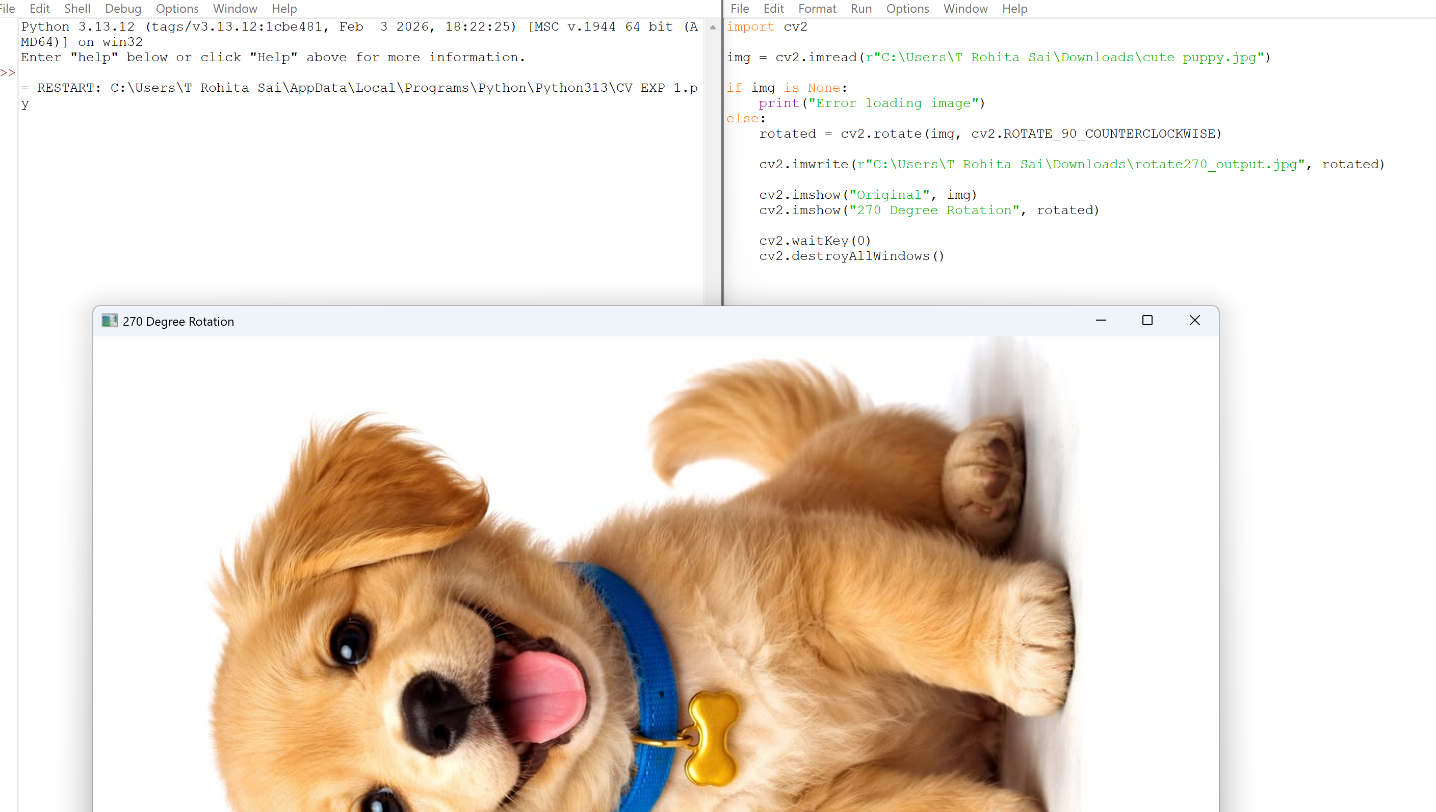
Experiment 13: Affine Transformation

Code
import cv2
import numpy as np
img = cv2.imread(r"C:\Users\T Rohita Sai\Downloads\cute puppy.jpg")
if img is None:
print("Error loading image")
else:
rows, cols, ch = img.shape
pts1 = np.float32([[50,50], [200,50], [50,200]])
pts2 = np.float32([[10,100], [200,50], [100,250]])
matrix = cv2.getAffineTransform(pts1, pts2)
affine = cv2.warpAffine(img, matrix, (cols, rows))
cv2.imwrite(r"C:\Users\T Rohita Sai\Downloads\affine_output.jpg", affine)
cv2.imshow("Original", img)
cv2.imshow("Affine Transformation", affine)
cv2.waitKey(0)
cv2.destroyAllWindows()
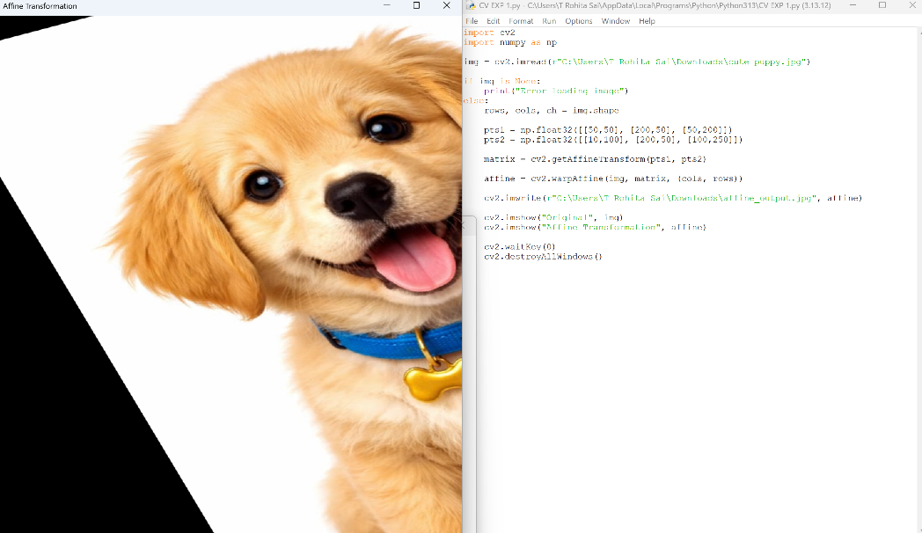
OUTPUT:

Experiment 14: Perspective Transformation
Code
import cv2
import numpy as np
img = cv2.imread(r"C:\Users\T Rohita Sai\Downloads\cute puppy.jpg")
if img is None:
print("Error loading image")
else:
rows, cols, ch = img.shape
pts1 = np.float32([[50,50], [200,50], [50,200], [200,200]])
pts2 = np.float32([[10,100], [200,50], [100,250], [220,220]])
matrix = cv2.getPerspectiveTransform(pts1, pts2)
perspective = cv2.warpPerspective(img, matrix, (cols, rows))
cv2.imwrite(r"C:\Users\T Rohita Sai\Downloads\perspective_output.jpg", perspective)
cv2.imshow("Original", img)
cv2.imshow("Perspective Transformation", perspective)
cv2.waitKey(0)
cv2.destroyAllWindows()
OUTPUT:
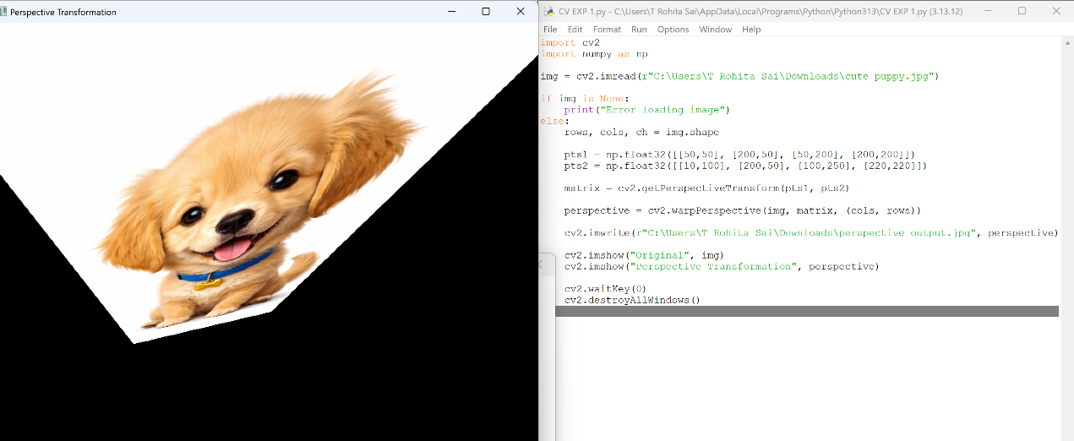

Experiment 15: Harris Corner Detection
Code
import cv2
import numpy as np
img = cv2.imread(r"C:\Users\T Rohita Sai\Downloads\cute puppy.jpg")
if img is None:
print("Error loading image")
else:
gray = cv2.cvtColor(img, cv2.COLOR_BGR2GRAY)
gray = np.float32(gray)
corners = cv2.cornerHarris(gray, 2, 3, 0.04)
img[corners > 0.01 * corners.max()] = [0, 0, 255]
cv2.imwrite(r"C:\Users\T Rohita Sai\Downloads\corners_output.jpg", img)
cv2.imshow("Harris Corners", img)
cv2.waitKey(0)
cv2.destroyAllWindows()
OUTPUT:
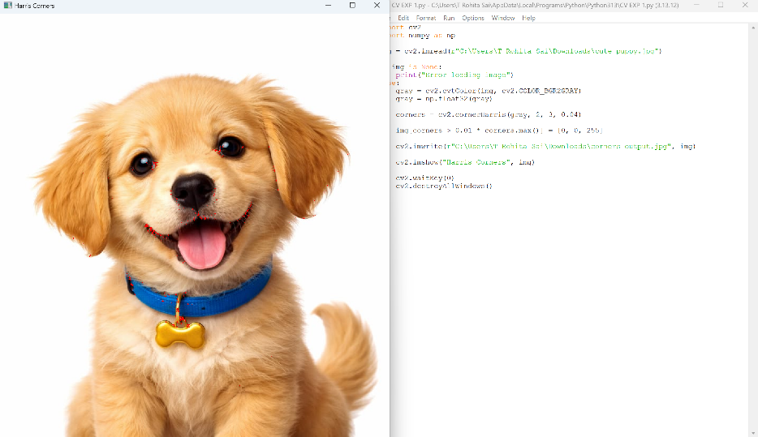

Experiment 16: Sobel Edge Detection
Code
import cv2
import numpy as np
img = cv2.imread(r"C:\Users\T Rohita Sai\Downloads\cute puppy.jpg")
if img is None:
print("Error loading image")
else:
gray = cv2.cvtColor(img, cv2.COLOR_BGR2GRAY)
sobelx = cv2.Sobel(gray, cv2.CV_64F, 1, 0, ksize=5)
sobely = cv2.Sobel(gray, cv2.CV_64F, 0, 1, ksize=5)
sobel = cv2.magnitude(sobelx, sobely)
cv2.imwrite(r"C:\Users\T Rohita Sai\Downloads\sobel_output.jpg", sobel)
cv2.imshow("Sobel Output", sobel / sobel.max())
cv2.waitKey(0)
cv2.destroyAllWindows()
OUTPUT:
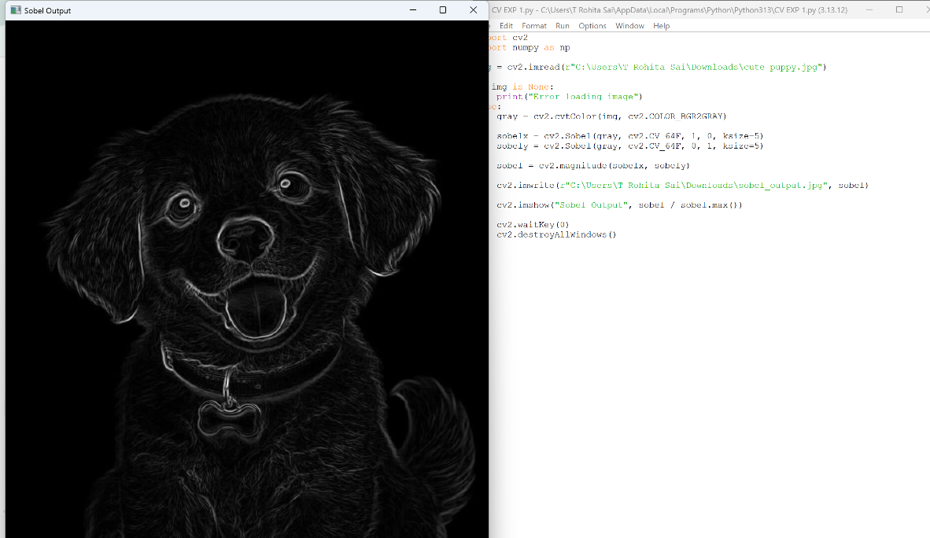

Experiment 17: Watermarking Technique
Code
import cv2
img = cv2.imread(r"C:\Users\T Rohita Sai\Downloads\cute puppy.jpg")
if img is None:
print("Error loading image")
else:
watermarked = img.copy()
cv2.putText(watermarked,
"Rohita",
(50, 50),
cv2.FONT_HERSHEY_SIMPLEX,
1,
(255, 255, 255),
2)
cv2.imwrite(r"C:\Users\T Rohita Sai\Downloads\watermark_output.jpg", watermarked)
cv2.imshow("Watermarked Image", watermarked)
cv2.waitKey(0)
cv2.destroyAllWindows()
OUTPUT:
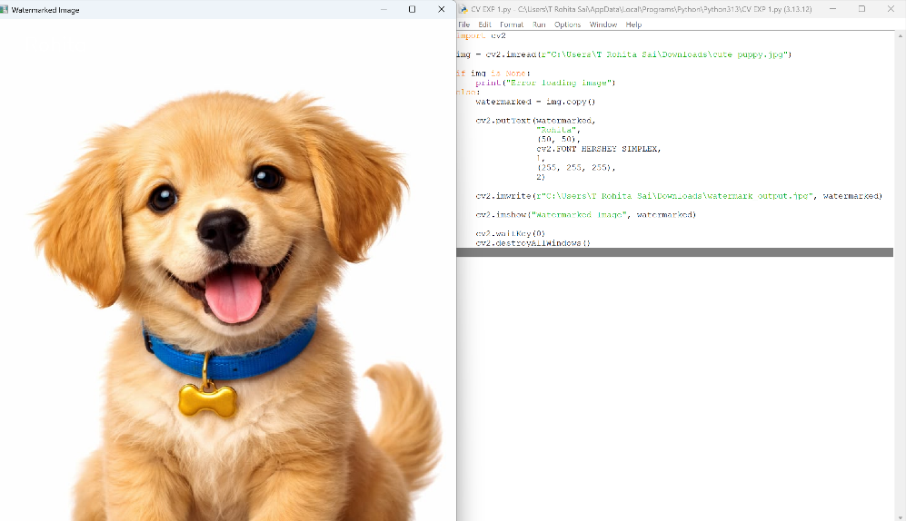

Experiment 18: Image Cropping, Copying and Pasting (ROI)

Code
import cv2
img = cv2.imread(r"C:\Users\T Rohita Sai\Downloads\cute puppy.jpg")
if img is None:
print("Error loading image")
else:
roi = img[50:200, 50:200]
img[250:400, 250:400] = roi
cv2.imwrite(r"C:\Users\T Rohita Sai\Downloads\roi_output.jpg", img)
cv2.imshow("ROI Copy Paste", img)
cv2.waitKey(0)
cv2.destroyAllWindows()
OUTPUT:
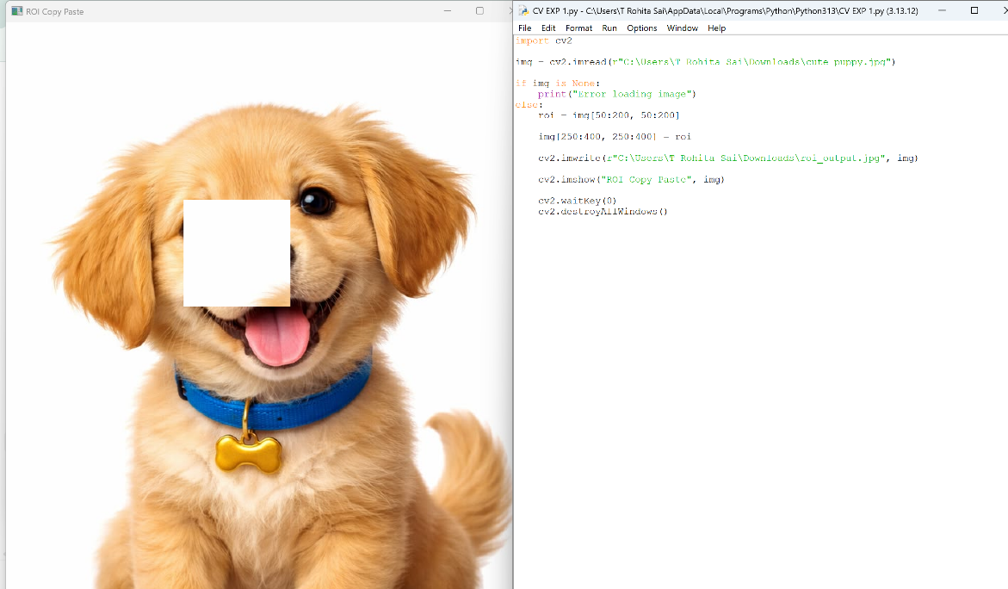

Experiment 19: Morphological Erosion
Code
import cv2
import numpy as np
img = cv2.imread(r"C:\Users\T Rohita Sai\Downloads\cute puppy.jpg")
if img is None:
print("Error loading image")
else:
kernel = np.ones((5,5), np.uint8)
erosion = cv2.erode(img, kernel, iterations=1)
cv2.imwrite(r"C:\Users\T Rohita Sai\Downloads\morph_erosion_output.jpg", erosion)
cv2.imshow("Morphological Erosion", erosion)
cv2.waitKey(0)
cv2.destroyAllWindows()
OUTPUT:
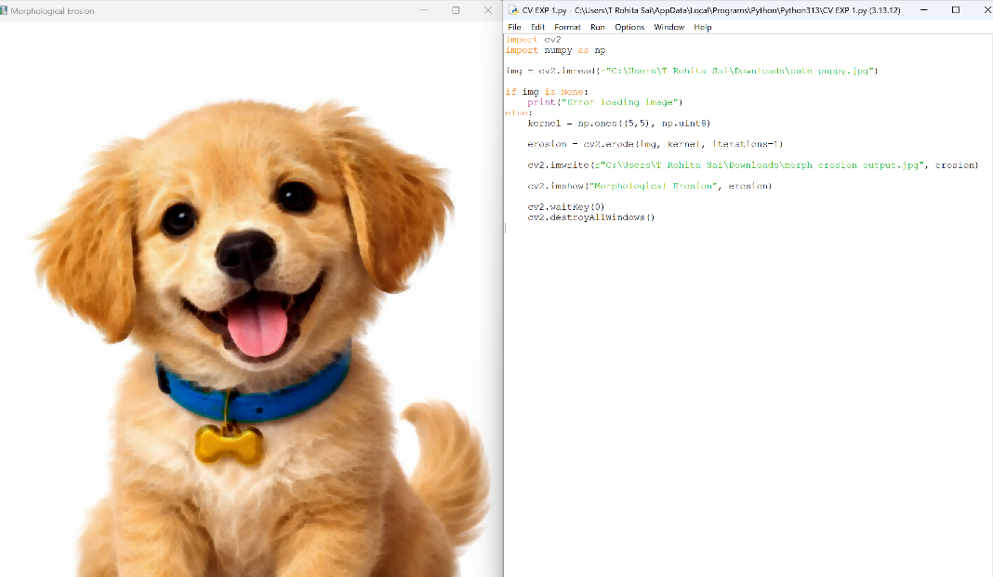

Experiment 20: Morphological Dilation
Code
import cv2
import numpy as np
img = cv2.imread(r"C:\Users\T Rohita Sai\Downloads\cute puppy.jpg")
if img is None:
print("Error loading image")
else:
kernel = np.ones((5,5), np.uint8)
dilation = cv2.dilate(img, kernel, iterations=1)
cv2.imwrite(r"C:\Users\T Rohita Sai\Downloads\dilation_output.jpg", dilation)
cv2.imshow("Morphological Dilation", dilation)
cv2.waitKey(0)
cv2.destroyAllWindows()
OUTPUT:
